**Project:** Project 0

**Report:** Descriptive Tables and Figures

**Investigator:** Rachel Johnson

**Date:** 6 September, 2017

**Table 1.** This table describes the demographics of the 103 individuals who remained in the study for the entire year; those with missing outcomes were excluded as they will be excluded from the analysis.

|  |  |  |  |  |  |
| --- | --- | --- | --- | --- | --- |
|  | **Placebo** | **Control** | **Low Dose** | **Medium Dose** | **High Dose** |
| **Sex (n (%))** |  |  |  |  |  |
| Male | 10 (0.43) | 7 (0.3) | 9 (0.43) | 7 (0.35) | 3 (0.19) |
| Female | 13 (0.57) | 16 (0.7) | 12 (0.57) | 13 (0.65) | 13 (0.81) |
| **Race (n (%))** |  |  |  |  |  |
| Native American | 0 (0) | 1 (0.04) | 1 (0.05) | 0 (0) | 1 (0.06) |
| African American | 1 (0.04) | 1 (0.04) | 3 (0.14) | 0 (0) | 1 (0.06) |
| Asian | 1 (0.04) | 1 (0.04) | 0 (0) | 1 (0.05) | 0 (0) |
| White | 21 (0.91) | 20 (0.87) | 17 (0.81) | 19 (0.95) | 14 (0.88) |
| **Age (mean (sd))** | 50.15 (9.95) | 50.15 (9.95) | 50.15 (9.95) | 50.15 (9.95) | 50.15 (9.95) |
| **Smoker (n (%))** |  |  |  |  |  |
| No | 13 (0.57) | 16 (0.7) | 15 (0.71) | 12 (0.6) | 11 (0.69) |
| Yes | 10 (0.43) | 7 (0.3) | 6 (0.29) | 9 (0.45) | 5 (0.31) |
| **Sites measured (mean (sd))** | 159.65 (10.66) | 153.91 (11.24) | 161.71 (8.16) | 153.5 (17.12) | 158.25 (8.73) |
| **Attachment at baseline (mean (sd))** | 1.83 (0.66) | 2.55 (0.65) | 2.1 (1.09) | 2.24 (0.67) | 2.31 (1.01) |
| **Attachment at 1 year (mean (sd))** | 1.74 (0.54) | 2.33 (0.55) | 2.08 (1.06) | 2.24 (0.65) | 2.15 (0.92) |
| **Pocket depth at baseline (mean (sd))** | 3.1 (0.39) | 3.29 (0.49) | 3.22 (0.64) | 3.05 (0.42) | 3.18 (0.28) |
| **Pocket depth at 1 year (mean (sd))** | 2.75 (0.48) | 2.95 (0.46) | 3.02 (0.58) | 2.84 (0.47) | 2.8 (0.42) |

**Figure 1**. This figure displays the yearly difference in attachment among the five treatment groups.

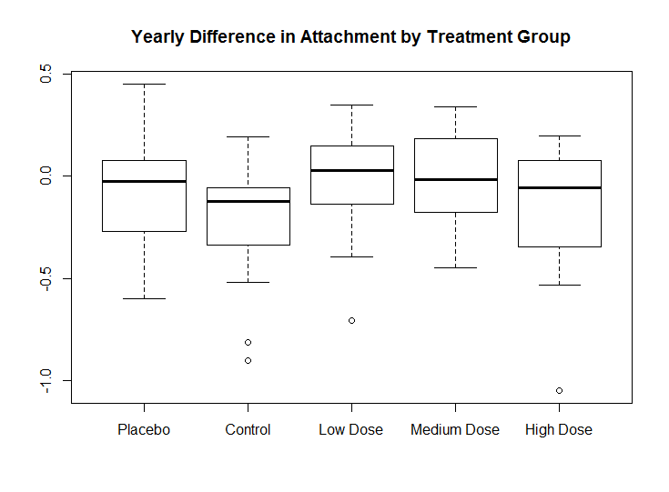

**Figure 2.** This figure displays the yearly difference in pocket depth among the five treatment groups.

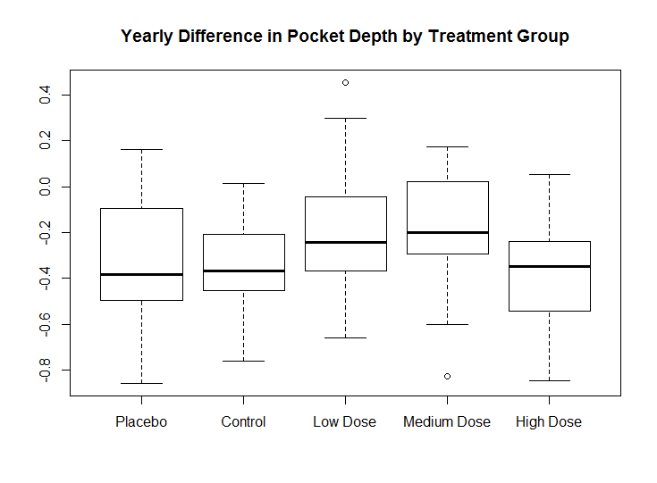

**Figure 3.** This figure shows the two outcomes graphed against one another. They are significantly correlated with one another (p < 0.001).

